Lesson 04 Demo 03

Connecting to a Windows Virtual Machine

Objective: To connect to a Windows virtual machine using Remote Desktop Protocol (RDP)
Tools Required: None

Prerequisites: Virtual machine (Lesson 4 Demo 1)

Steps to be followed:
- Connect to the virtual machine

Step 1: Connect to the virtual machine

  - On the virtual machine's overview page, click on Connect, click on Select under Native RDP section, and then click on Download RDP file

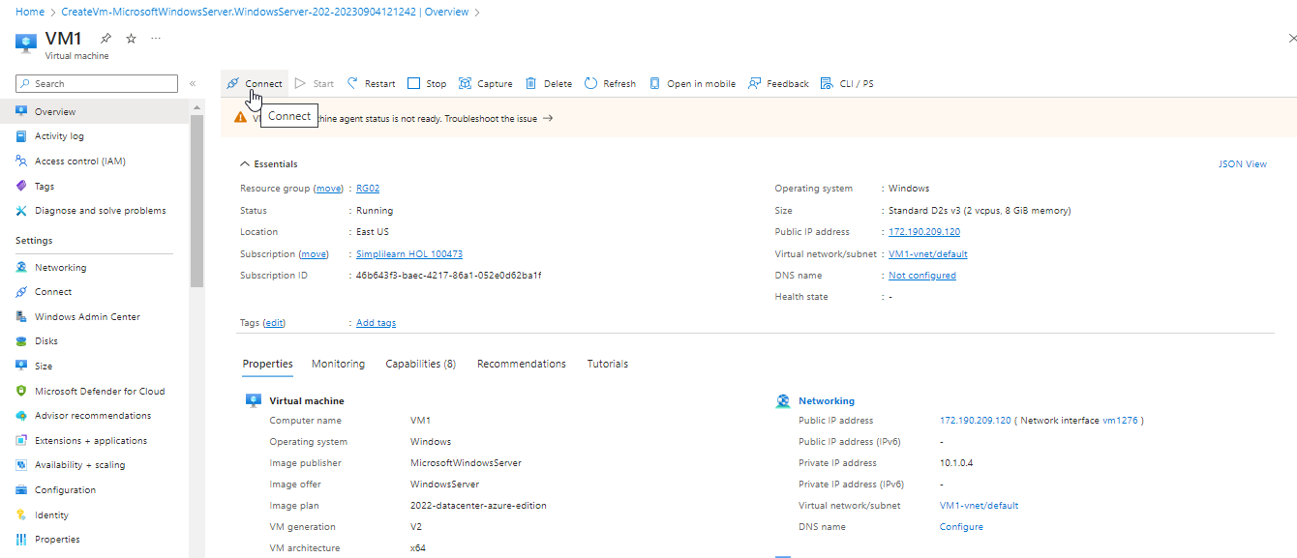

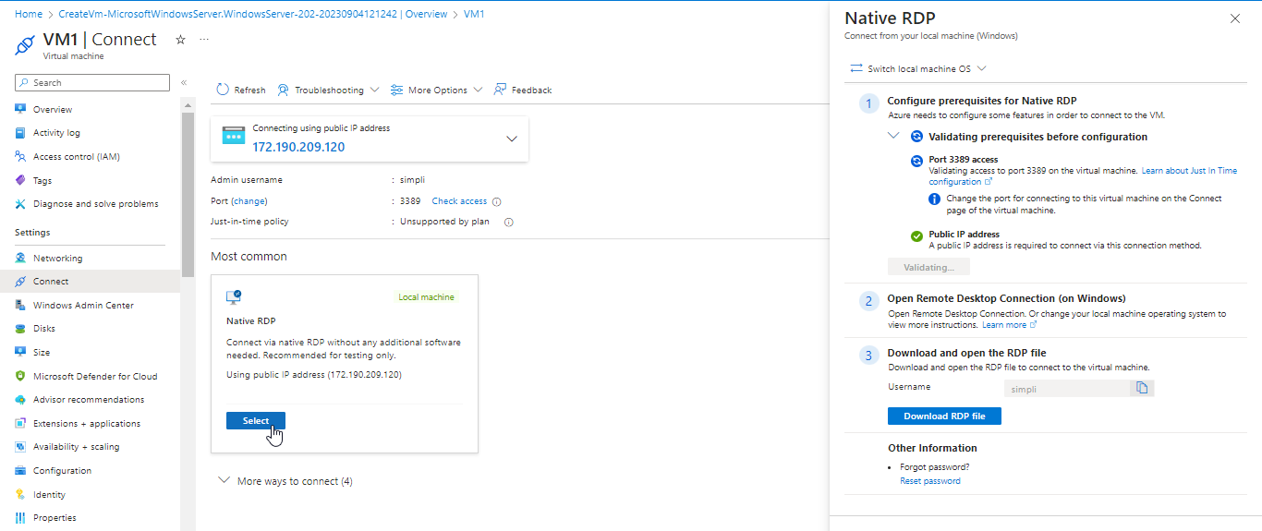

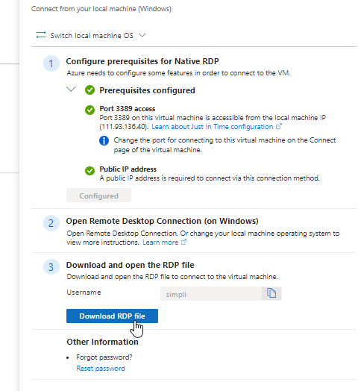

  - Open the downloaded RDP file and click on Connect when prompted

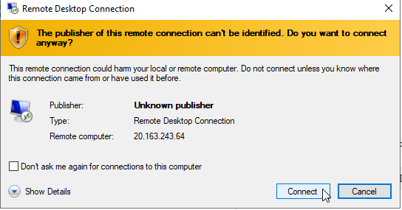

  - In the Windows Security window, enter the username as localhost\username, input the password established for the virtual machine, and click OK

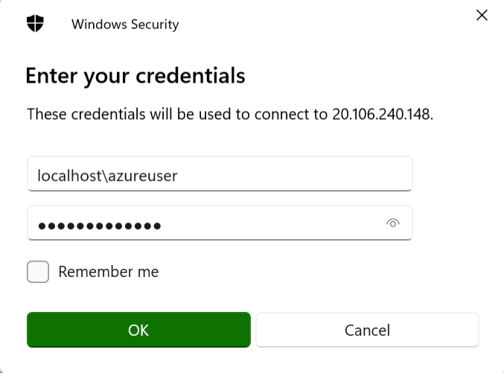

You have now successfully connected to a Windows-based virtual machine using RDP.

